# **Normal \ Gaussian Distribution**

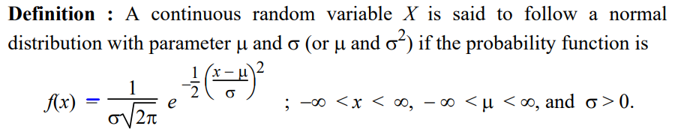  


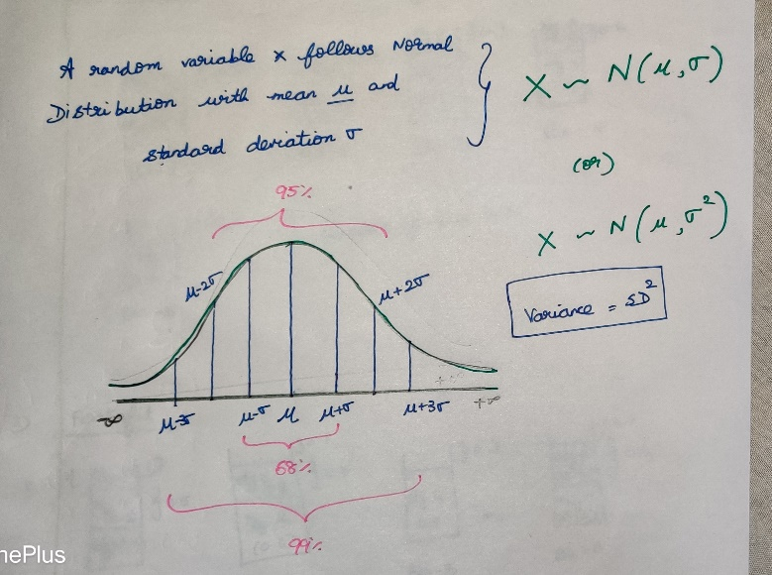

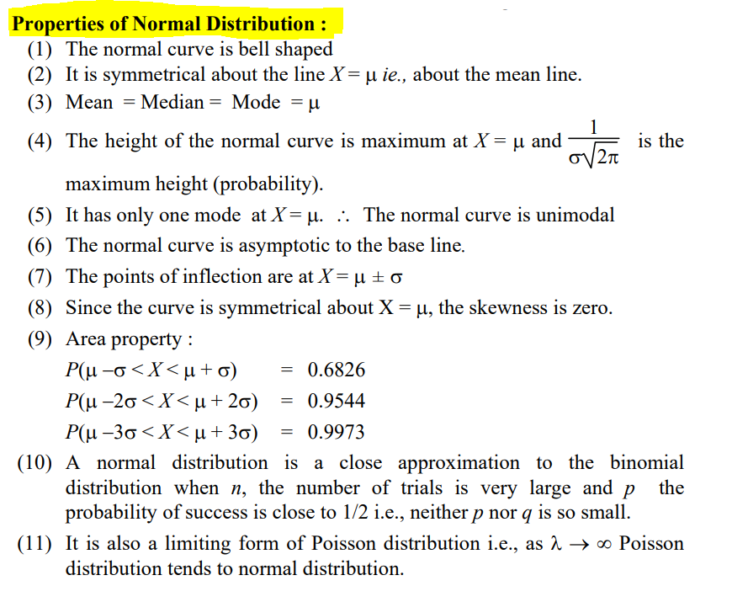

**Practical example**  
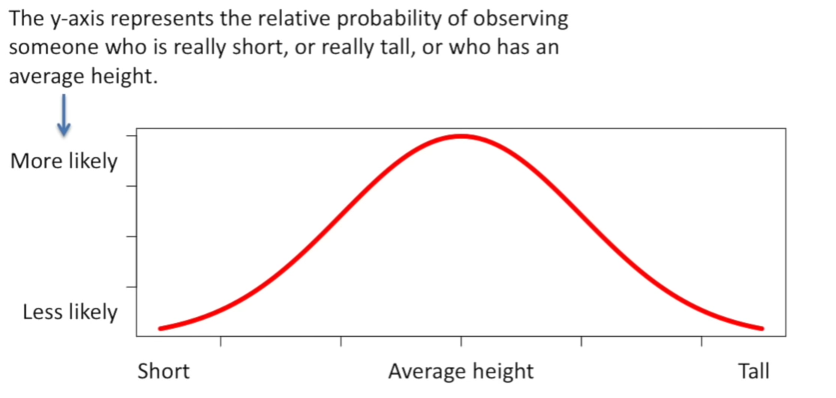

Its relatively rare to see a person who is super short.  
Its quite common to see some-one who is close to the average height.  
Its relatively rare to see a person who is very tall.

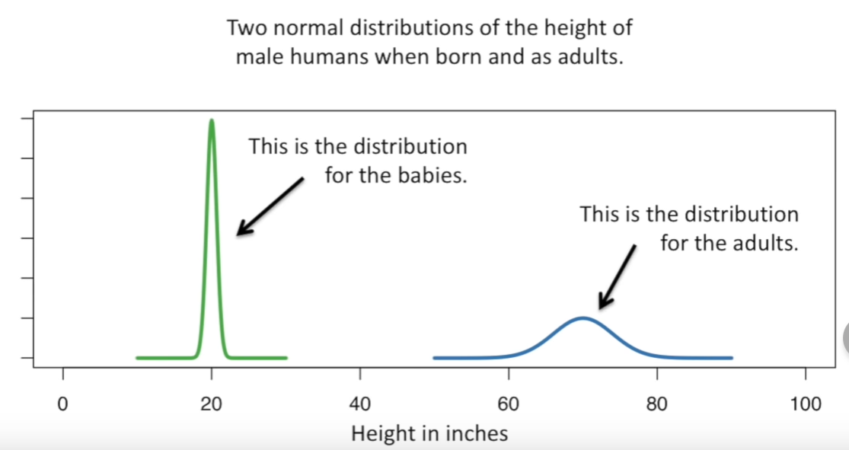

Average baby heights 🡪 20 inches  
Average adult heights 🡪 70 inches

Normal Distribution are always cantered on the average values.

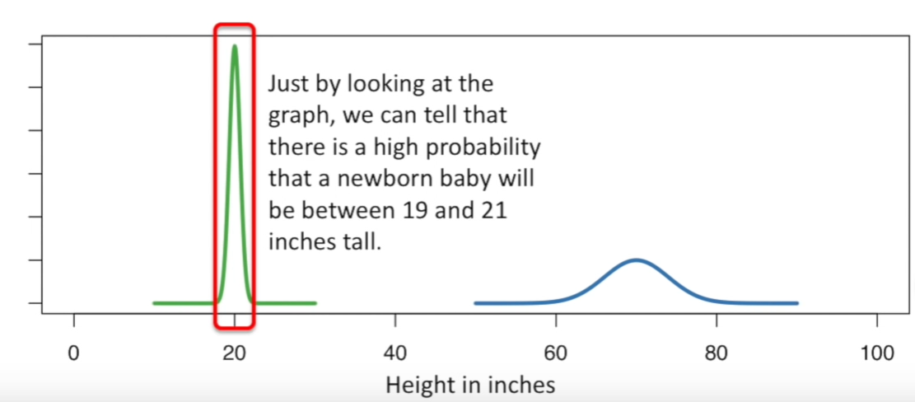

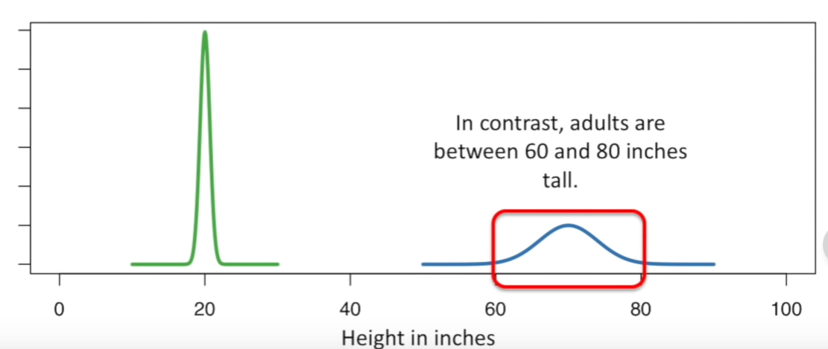

The curve for babies is more tall when compared to curve for adults.  
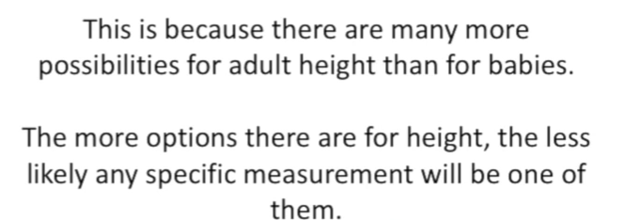

The width of the curve is defined by the standard deviation.  
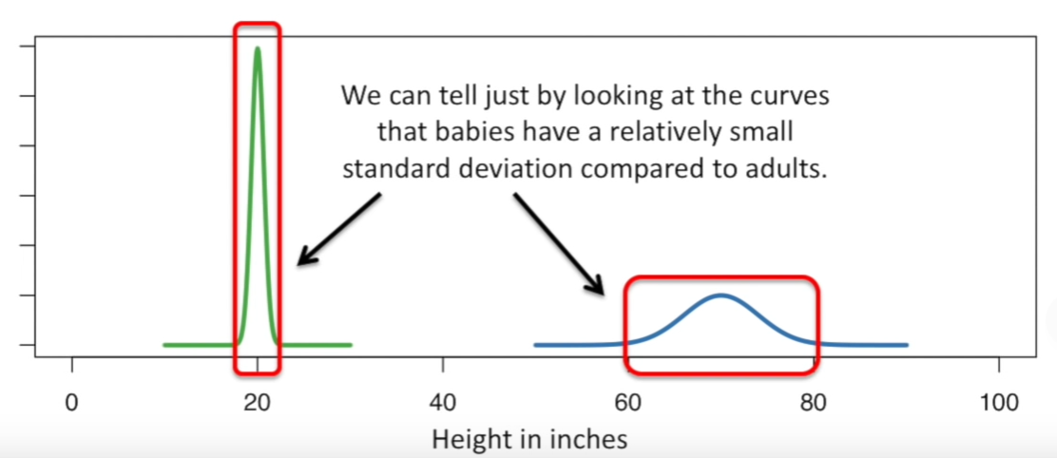

Standard deviation for babies for babies 🡪 0.6  
Standard deviation for babies for adults 🡪 4

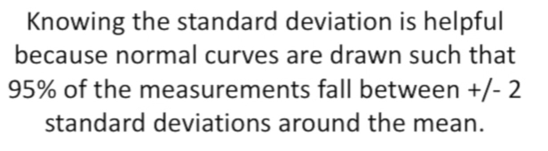

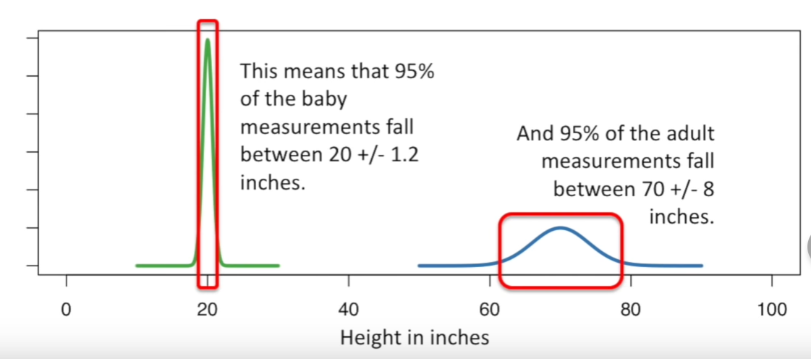

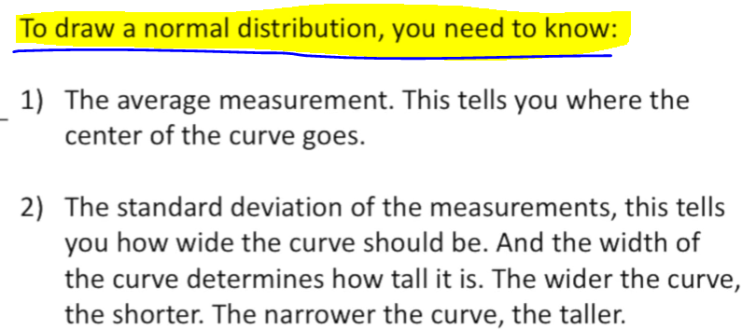

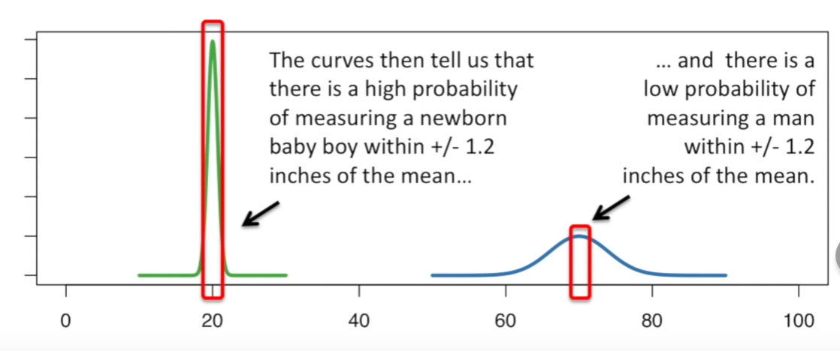

# **Standard Normal Distribution**

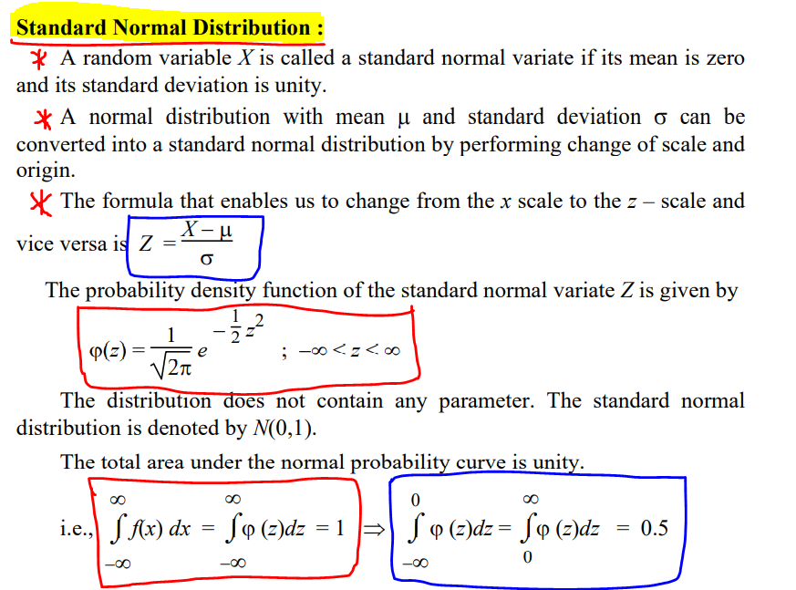

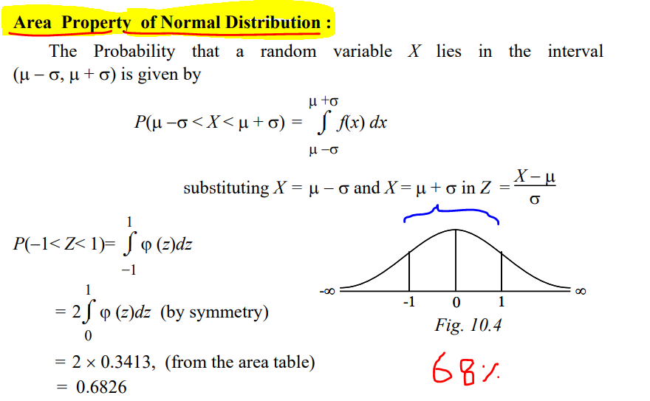

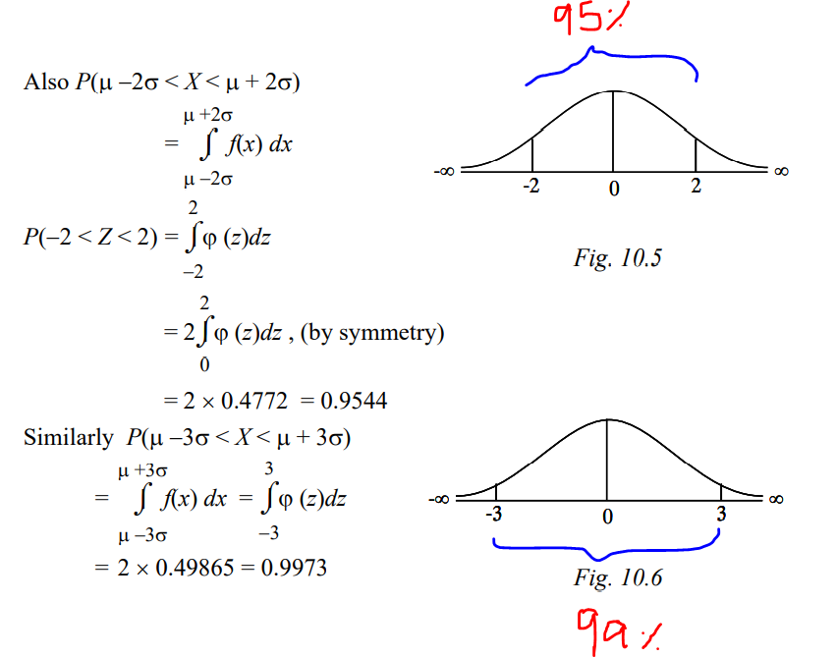

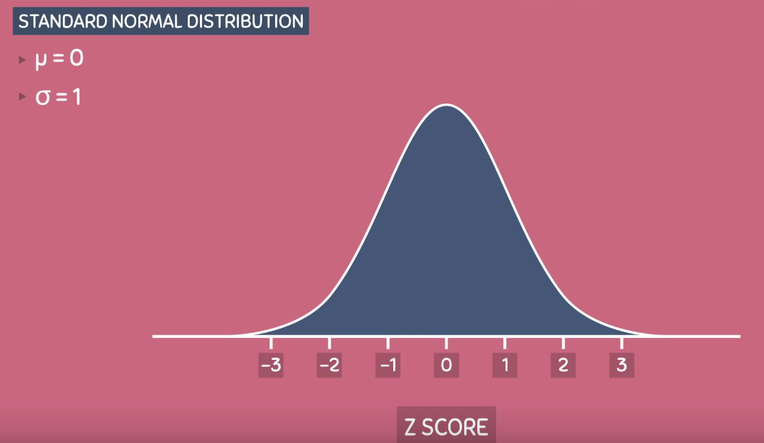

Because of this, the standard normal distribution is always centred at 0 and has intervals that increase by 1 each number on the horizontal axis corresponds to Z-score.

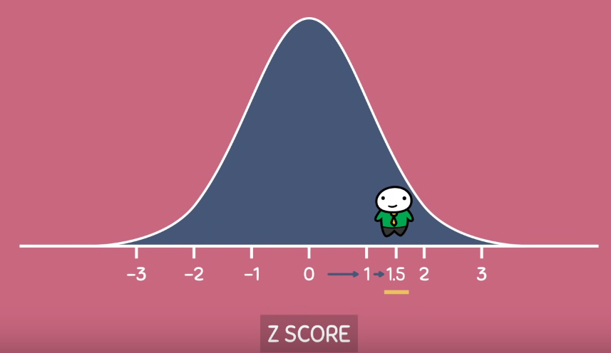

A Z-score will tell how many standard deviations an observation is from the mean.

Eg: Z-score of 1.5 tells that the observation is 1.5 standard deviation from the right of the mean.

Any Normal/Gaussian Distribution can be converted into Standard Normal Distribution.  
This converting process is called Standardization.

